FINAL PROJECT REPORT

DOCSPOT: Seamless Appointment Booking For Health

**Team ID: LTVIP2025TMID55946**

# INTRODUCTION

The purpose of Booking a Doctor Appointment is an innovative healthcare booking platform designed to streamline the process of connecting patients with healthcare providers. This system enables users to easily find, schedule, and manage medical appointments, all within a user-friendly interface. By offering functionalities like doctor browsing, appointment scheduling, and secure document uploading, the app caters to the needs of patients, doctors, and administrators alike

* 1. **Project Overview**
     + The **Doctor booking app- Book a Doctor** is a full-stack web application built using the MERN stack (MongoDB, Express.js, React.js, and Node.js).
     + This platform bridges Patients can search for doctors based on specialty, locatility and availability ensuring they find the right healthcare professional for their needs. Once a suitable doctor and users can book appointments, manage their schedules, and receive notifications and reminders. Doctors benefit from a dedicated interface to manage appointments, update patient records, and communicate effectively, while administrators oversee the app's smooth operation, ensuring compliance and resolving any disputes.

**Key Highlights:**

**1. User-Centric Interface**

* Intuitive UI/UX for patients, caregivers, and doctors.
* Multi-platform access: Web, mobile, and tablet support.

**2. Real-Time Availability**

* Live calendar sync with doctors’ schedules.
* Instant booking and cancellation options.

**3. Integrated Notifications**

* SMS, email, and app push notifications for confirmations, reminders, and rescheduling.
  1. **Purpose**

The main purpose is the:

* Improve patient access to care by enabling quick and convenient appointment booking.
* Reduce administrative burden on hospital or clinic staff through automation.

# 2 IDEATION PHASE

* 1. **Problem Statement**

In many healthcare facilities, patients face significant challenges when trying to book appointments, including long wait times, lack of real-time availability, limited access to doctors, and inefficient communication. Traditional systems are often manual, fragmented, or not user-friendly, leading to missed appointments, scheduling errors, and patient dissatisfaction.

* 1. **Empathy Map Canvas**

**Says :**

* Why is it so hard to get an appointment
* I don’t know which doctor to choose
* I didn’t get any confirmation or reminde

**Thinks** :

* Will I be able to find a good doctor in time
* I hope my data is secure.
* This process should be easier

**Does :**

* Searches online or calls multiple times to book.
* Asks friends or family for recommendations.
* Visits the hospital physically to check availability.
* Cancels or forgets appointments due to poor reminders.
  1. **Brainstormed Features**
     + Real-Time Appointment Booking
     + Doctor Search & Filter
     + Search by specialty, location, language, gender, ratings, or availability.
     + AI-powered suggestions based on symptoms, history, and location.
     + One-Click Booking & Rescheduling
     + Simple, fast appointment setup with easy options to reschedule or cancel.
     + Integrated Telemedicine Support

# REQUIREMENT ANALYSIS

The requirement analysis identifies the key needs for building a seamless appointment booking system in healthcare. It must allow patients to easily book, reschedule, or cancel appointments and receive timely reminders. Doctors should be able to manage their schedules and access patient information, while admins oversee the system and generate reports. The platform must be secure, user-friendly, scalable, and accessible across devices.

* 1. **Patient Journey Map**

The **Patient Journey Map** outlines the step-by-step experience a patient goes through when booking and attending a healthcare appointment using a seamless digital system. It starts when the patient realizes they need medical care and continues through searching for the right doctor, booking an appointment, receiving confirmations and reminders, attending the consultation (in-person or virtual), and finally managing follow-ups or feedback.

This journey highlights the patient’s needs and emotions at each stage, helping healthcare providers identify pain points like complicated booking steps, missed reminders, or long wait times. By understanding this journey, the appointment system can be designed to offer a smooth, efficient, and user-friendly experience that reduces frustration, improves access to care, and ensures better communication.

Ultimately, the goal is to make healthcare more accessible, reliable, and convenient for patients by using technology that simplifies the entire appointment process from start to finish.

|  |  |  |  |
| --- | --- | --- | --- |
| **Stage** | **Patient Actions** | **Thoughts/Needs** | **Pain Points** |
| 1. **Awareness** | Realizes the need to see a doctor | “Who should I consult?” “Where can I find help?” | Uncertainty about finding the right specialist |
| 2. **Search** | Visits app/website to find a doctor | “I need someone nearby and available soon.” | Complex search process Lack of availability info |
| 3. **Booking** | Selects doctor and time slot, confirms appointment | “Was the booking successful?” | Confusing booking steps No confirmation received |
| 4. **Preparation** | Waits for appointment, receives reminders | “I don’t want to miss this.” | Missed reminders No instructions before visit |
| 5. **Consultation** | Visits doctor physically or joins online consultation | “Will the doctor understand my issue?” | Long wait times Tech issues during teleconsult |
| 6. **Post-Visit** | Views prescription, feedback, or schedules follow-up | “How can I follow up or see my report?” | No clear next steps or follow-up system |
| |  | | --- | | **Visit / Consultation** |  |  | | --- | |  | | **Patient visits the clinic or attends a virtual consultation with the doctor.** |  |  |

* 1. **Solution Requirements**

Minimize wait time and booking friction and Enhance communication and clarity and Deliver a smooth and secure healthcare experience

**Functional Requirements**

The seamless appointment booking system must allow patients to securely register and log in using email, phone, or social accounts, with support for password recovery and multi-factor authentication. Patients should be able to easily search for doctors based on specialty, location, availability, language, and ratings. The system will display real-time appointment slots, enabling patients to book, reschedule, or cancel both in-person and virtual consultations with ease. Automated notifications via SMS, email, and app push will keep patients informed about confirmations, reminders, cancellations, and follow-ups. Patients can manage their profiles, including personal details, medical history, and appointment records, while doctors will have access to a dashboard for managing their schedules and viewing patient information. Administrators will oversee user and appointment management through an admin panel with reporting capabilities

**Non-Functional Requirements**

The system must deliver high performance, ensuring fast response times even during peak usage, and be scalable to accommodate increasing numbers of users and healthcare providers across multiple locations. It should guarantee 99.9% uptime to maintain continuous availability for patients and staff. Security is paramount, so the platform must comply with healthcare regulations such as HIPAA and GDPR, implementing strong encryption, secure authentication methods, and regular audits to protect sensitive patient data. The system should be accessible across various devices and operating systems, including web browsers and mobile platforms (iOS and Android), with support for multiple languages and accessibility standards to serve users with disabilities. Additionally, the architecture should be modular and maintainable, enabling easy updates, bug fixes, and integration with existing hospital management systems and electronic health records

**3.3 Data Flow Diagram (DFD)**

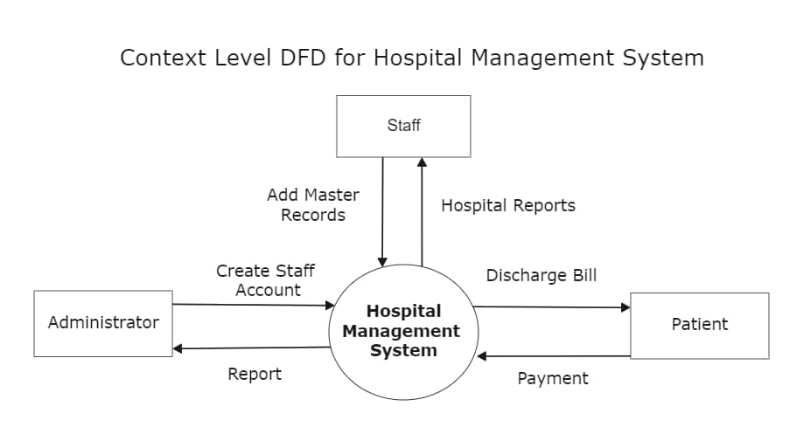

A **Data Flow Diagram (DFD)** is a visual tool that illustrates how data moves through a system. It shows the flow of information between different parts of the system, such as users, processes, data stores, and external entities. For a seamless appointment booking system, a DFD helps map out how patient requests (like searching for doctors or booking appointments) travel through the application, how the system processes these requests, and how responses or notifications are sent back.

The DFD typically has four main components:

* **External Entities:** Users or other systems interacting with the system (e.g., patients, doctors, admin).
* **Processes:** Actions or functions the system performs (e.g., booking an appointment, sending reminders).
* **Data Stores:** Where information is stored (e.g., patient records, appointment schedules).
* **Data Flows:** The movement of data between entities, processes, and stores.

By using a DFD, developers and stakeholders can better understand system requirements, identify potential bottlenecks, and design an efficient and clear workflow for the appointment booking system.

**Level 0 – Context Diagram**

* **Purpose:** Provides a high-level overview of the entire system as a single process.
* **What it shows:** The system as a whole interacting with external entities (like patients, doctors, and admin). It depicts the flow of data between the system and these external entities but doesn’t show internal workings.
* **Example:** For the appointment system, Level 0 shows “Appointment Booking System” as one process with data flows like “Appointment Request” from the patient and “Appointment Confirmation” back to the patient.

**Level 1 – Decomposition Diagram**

* **Purpose:** Breaks the main system process into major sub-processes or modules to show key functions.
* **What it shows:** Internal processes like “User Registration,” “Doctor Search,” “Appointment Scheduling,” “Notification Management,” and “Patient Profile Management.” It also shows data stores such as “Patient Records” and “Doctor Schedules.”
* **Example:** Level 1 details how patient requests are handled by different components inside the system

**Level 2 (and beyond) – Detailed Decomposition**

* **Purpose:** Further breaks down each Level 1 process into smaller, more detailed sub-processes.
* **What it shows:** Fine-grained steps, like “Verify User Credentials” inside the “User Registration” process, or “Check Doctor Availability” inside “Appointment Scheduling.”
* **Example:** Level 2 might illustrate how notifications are prepared and sent, including checking notification preferences and scheduling reminders.

### **Summary Table**

|  |  |  |
| --- | --- | --- |
| **Level** | **Description** | **Example in Appointment System** |
| **Level 0** | Context diagram: system as one process | Appointment Booking System interacts with patients, doctors |
| **Level 1** | Major system modules & data stores | User Registration, Doctor Search, Appointment Scheduling |
| **Level 2** | Detailed sub-processes | Verify credentials, Check availability, Send reminders |

The table breaks down the **levels of a Data Flow Diagram (DFD)**, which are used to represent the flow of data within a system at different degrees of detail.

**Level 0 (Context Diagram):**

This is the highest-level view of the entire system shown as a single process. It illustrates how the **Appointment Booking System** interacts with external entities like patients and doctors. At this stage, the focus is on the overall inputs and outputs between the system and users, without showing internal workings. It helps stakeholders quickly understand what the system does and who it communicates with.

**Level 1 (Major System Modules & Data Stores):**

Here, the system is broken down into key functional areas or modules such as **User Registration**, **Doctor Search**, and **Appointment Scheduling**. It also shows major data stores like patient records and doctor schedules. This level reveals how the system organizes its core functionalities and handles data but still abstracts the detailed processes within each module.

**Level 2 (Detailed Sub-Processes):**

This level further decomposes the modules from Level 1 into smaller, specific tasks. For example, within User Registration, sub-processes like **Verify Credentials** are defined; in Appointment Scheduling, tasks such as **Check Doctor Availability** and **Send Reminders** are shown. This detailed breakdown is essential for developers to understand exactly how the system operates internally and to guide system design and implementation.

* 1. **Technology Stack**
     + **Frontend**

**Frameworks/Libraries:** React.js / Angular / Vue.js — for building responsive, user-friendly web interfaces.

* + - **Mobile:** React Native / Flutter — for cross-platform mobile apps (iOS & Android).

**UI Components:** Material-UI / Bootstrap / Tailwind CSS — to speed up UI development.

* + - **Backend**

**Language:** Node.js (with Express) / Python (Django/Flask) / Java (Spring Boot) — for building scalable APIs and business logic.

**API Style:** RESTful API or GraphQL — to communicate between frontend and backend.

* + - **Database**

**Relational:** PostgreSQL / MySQL — for structured data like patient records, appointments, and doctor info.

**NoSQL:** MongoDB — for flexible data storage if needed (e.g., logs, sessions).

* + - **4. Authentication & Security**

**OAuth 2.0 / JWT** — for secure user authentication and authorization.

**Encryption:** TLS/SSL for data in transit, AES for data at rest.

**Security tools:** OWASP guidelines, regular vulnerability scans.

* + - **Notifications**

**Email:** SendGrid / Amazon SES / Mailgun — for sending emails.

**SMS:** Twilio / Nexmo — for SMS reminders and alerts.

**Push Notifications:** Firebase Cloud Messaging (FCM) for mobile app notifications.

* + - **Video & Telemedicine Integration**

**WebRTC / Twilio Video / Zoom SDK** — for secure video consultations.

* + - **Cloud & Hosting**

**Cloud Providers:** AWS / Azure / Google Cloud — for scalable hosting, databases, and storage.

**Containerization:** Docker + Kubernetes — for easy deployment and scaling.

* + - **8. Monitoring & Analytics**

**Tools:** Prometheus, Grafana, Google Analytics — to monitor system performance and usage.

# PROJECT DESIGN :

* 1. **Problem-Solution Fit**

**Problem-Solution Fit** means ensuring that the solution you’re building directly addresses the core problems faced by your users—in this case, patients, doctors, and healthcare administrators—in a meaningful and effective way.

**The Problem:**  
Patients struggle with complicated and time-consuming appointment booking processes, resulting in long wait times, missed appointments, and poor communication. Doctors and clinics face challenges in managing schedules efficiently and keeping patients informed, leading to underutilized resources and patient dissatisfaction.

**The Solution:**  
A seamless appointment booking system that simplifies the process by providing real-time doctor availability, easy search and booking, automated reminders, and options for both in-person and virtual consultations. The system also enables doctors to manage their schedules effortlessly and helps admins oversee operations smoothly.

**Problem-Solution Fit occurs when:**

* Patients find booking faster, easier, and more reliable.
* Doctors can optimize their appointment slots and reduce no-shows.
* Admins gain better control and insights over clinic workflows.
* Overall, the system improves access to healthcare and patient satisfaction.

Confirming this fit early ensures that the project addresses real user pain points and increases the likelihood of adoption and success.

* 1. **Proposed Solution**

The proposed solution is a **Seamless Appointment Booking System** designed to simplify and enhance the healthcare appointment experience for patients, doctors, and administrators. This digital platform will allow patients to easily search for doctors by specialty, location, and availability, and book appointments in real time—whether for in-person visits or virtual consultations.

The system will provide automated notifications and reminders to reduce missed appointments, enable doctors to efficiently manage their schedules through an intuitive dashboard, and offer administrators tools to oversee and optimize clinic operations. Built with security, accessibility, and scalability in mind, the solution will support multiple devices and languages, ensuring it meets diverse patient needs while complying with healthcare data privacy regulations.

* 1. **Solution Architecture**

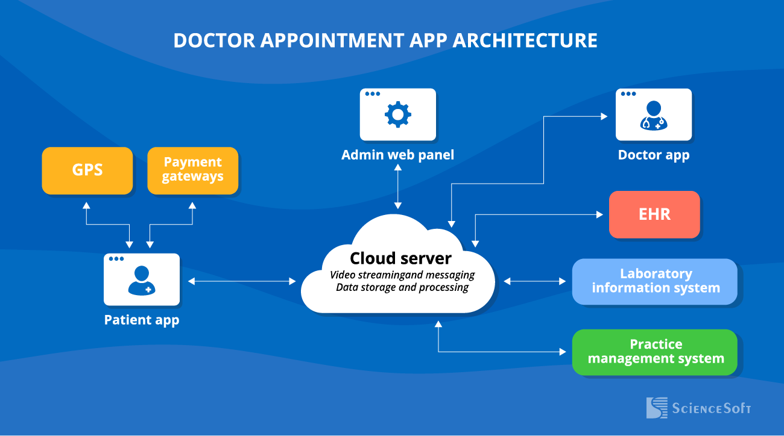

The architecture of the Seamless Appointment Booking System is designed to be scalable, secure, and user-friendly. It follows a typical **3-tier architecture**: **Frontend**, **Backend (API Layer)**, and **Data Storage** — all deployed on reliable servers or cloud infrastructure.

**1. Frontend Layer**

* **Role:**  
  This is the user interface where patients, doctors, and admins interact with the system. It includes web and mobile apps that provide search, booking, scheduling, notifications, and profile management features.
* **Technology & Server:**
  + Built with React.js, Angular, or Vue.js for the web frontend.
  + Mobile apps with React Native or Flutter.
  + Hosted on CDN-backed web servers (e.g., **AWS S3 + CloudFront**, **Netlify**, or **Vercel**) to ensure fast content delivery globally.

**2. Backend Layer (API Server)**

* **Role:**  
  The backend handles business logic, processes user requests, communicates with the database, and manages security and authentication. It exposes RESTful or GraphQL APIs consumed by the frontend.
* **Technology & Server:**
  + Implemented using Node.js with Express, Python with Django/Flask, or Java with Spring Boot.
  + Deployed on scalable cloud servers or container orchestration platforms like **AWS EC2 / Elastic Beanstalk**, **Azure App Service**, **Google Cloud Compute Engine**, or **Kubernetes clusters**.
  + Load balancers (e.g., AWS ELB) ensure even traffic distribution and high availability.

**3. Storage Layer (FSD - File, Storage, Database)**

* **Role:**  
  This layer stores all persistent data such as user profiles, appointment details, doctor schedules, medical records, and logs.
* **Technology & Servers:**
  + **Relational Database:** PostgreSQL or MySQL hosted on managed cloud database services like **Amazon RDS**, **Azure Database for PostgreSQL**, or **Google Cloud SQL** for structured data.
  + **NoSQL Database:** MongoDB Atlas or DynamoDB for flexible data such as session info or logs.
  + **File Storage:** AWS S3, Azure Blob Storage, or Google Cloud Storage for storing documents,

**4 . Notification & Communication Services**

* Services like Twilio (SMS), SendGrid (email), and Firebase Cloud Messaging (FCM) (push notifications) will be integrated for sending appointment confirmations, reminders, and alerts.

**5. Security & Compliance**

* HTTPS/TLS encryption on all communication layers.
* OAuth 2.0 / JWT for authentication and authorization.
* Data encrypted at rest and in transit.
* Regular security audits and compliance with HIPAA/GDPR regulations.
* **Frontend: React.js/Flutter hosted on CDN-backed web servers for fast access.**
* **Backend: Node.js/Django on scalable cloud servers or Kubernetes for reliable API delivery.**
* **Storage (FSD): Managed relational and NoSQL databases plus cloud file storage for secure and scalable data management.**
* **Additional Services: Notification platforms and strong security mechanisms to ensure smooth, safe operations.**

# PROJECT PLANNING & SCHEDULING

* 1. **Project Planning**
* Build a user-friendly platform to enable patients to book appointments with doctors seamlessly.
* Include features like real-time doctor availability, notifications, virtual consultations, and secure patient profiles.
* Ensure compliance with healthcare data security standards.

**Product Backlog and Sprint Planning:**

|  |  |
| --- | --- |
| **Phase** | **Key Tasks** |
| Requirement Analysis | Gather user needs, define features, prepare requirement docs |
| System Design | Design system architecture, database schema, UI/UX designs |
| Frontend Development | Develop web/mobile interfaces, user registration, booking UI |
| Backend Development | Develop APIs, authentication, scheduling logic, notifications |
| Integration | Connect frontend, backend, notification, telemedicine APIs |
| Testing | Unit testing, integration testing, user acceptance testing |
| Deployment | Deploy on cloud servers, configure databases and services |
| Training & Documentation | Prepare user manuals, conduct training sessions |
| Maintenance & Support | Monitor system, fix bugs, deploy updates |

**Resource Allocation**

|  |  |  |
| --- | --- | --- |
| **Role** | **Responsibilities** | **Estimated Effort** |
| Project Manager | Planning, tracking, communication | Full project duration |
| Business Analyst | Requirements gathering, documentation | Weeks 1–2 |
| UI/UX Designer | Design wireframes and user interfaces | Weeks 3–4 |
| Frontend Developer | Develop client applications | Weeks 5–9 |
| Backend Developer | Develop API, database, authentication | Weeks 5–9 |
| QA Engineer | Testing and bug tracking | Weeks 10–12 |
| DevOps Engineer | Deployment, server setup, monitoring | Weeks 12–13 |
| Trainer | User training and documentation | Week 13 |

1. **Risk Management**

* **Delays in Development:** Mitigate by setting realistic deadlines and regular progress reviews.
* **Integration Issues:** Early and continuous integration testing.
* **Security Concerns:** Regular audits and compliance checks.
* **User Adoption:** Plan user training and gather feedback early.

1. **Communication Plan**

* Weekly status meetings with the project team.
* Bi-weekly stakeholder updates.
* Use collaboration tools like Jira, Trello, or Asana to track progress.

1. **FUNCTIONAL AND PERFORMANCE TESTING**
   1. **Performance Testing**

**Booking a Doctor:** To ensure the appointment booking platform can handle multiple users simultaneously booking, searching, and managing appointments without delays or failures, maintaining a smooth user experience under different load conditions.

* **Concurrent User Load:**

Simulate hundreds or thousands of patients and doctors using the system at the same time—searching doctors, booking appointments, canceling/rescheduling, and logging in/out.

* **Real-time Availability Checks:**

Measure response time when patients query doctor availability in real time.

* **Appointment Booking Workflow**:

Test the end-to-end booking process including authentication, slot selection, booking confirmation, and notification sending.

* **Notification Handling:**

Test performance for sending appointment reminders via email, SMS, and push notifications to ensure timely delivery under load.

**Performance Testing Types Applied:**

* **Load Testing:**  
  Simulate average and peak user loads to ensure the system meets response time goals (e.g., booking should complete within 2-3 seconds).
* **Stress Testing:**  
  Push system beyond normal capacity to identify breaking points and evaluate how gracefully the system degrades or recovers.
* **Spike Testing:**  
  Simulate sudden spikes in traffic during events like health drives to verify system stability and quick recovery.
* **Endurance Testing:**  
  Run continuous load over extended periods to check for memory leaks or resource exhaustion.

**Testing Scope :**

* **Functional Testing:** Verify core features like user registration, doctor search, appointment booking/rescheduling, and notification delivery.
* **Integration Testing:** Ensure smooth interaction between frontend, backend APIs, database, and third-party services (e.g., SMS/email).
* **Performance Testing:** Test system response under load (many users booking at once) to check speed, stability, and scalability.
* **Security Testing:** Check for secure login, data protection, role-based access control, and compliance with healthcare data privacy standards.
* **Compatibility & Usability Testing:** Confirm that the system works across devices (mobile,

desktop), browsers, and offers a user-friendly interface.

* **User Acceptance Testing (UAT):** Involve real users (patients/doctors) to ensure the system meets real-world needs and expectations before launch.

**Requirements to Be Tested :**

* **User Registration & Login**
  + Patients and doctors must be able to register, log in, and reset passwords securely.
  + Role-based access must be enforced (e.g., patient vs. doctor vs. admin).
* **Doctor Search & Filtering**
  + Patients should be able to search doctors by specialization, availability, location, and language.
  + Search results must be accurate and fast.
* **Appointment Booking Flow**
  + Real-time slot availability should be displayed.
  + Patients must be able to book, cancel, and reschedule appointments.
  + Bookings must be correctly reflected in the doctor’s schedule.

## Testing environment:

**Credentials:**

| **Role** | **Email / Username** | **Password** |
| --- | --- | --- |
| Patient | test.patient@example.com | patient123 |
| Doctor | test.doctor@example.com | doctor123 |
| Admin | admin@appointmenthealth.com | adminpass |

**Testcases:**

**User Registration & Login:**

|  |  |  |
| --- | --- | --- |
| **Test Case ID** | **Description** | **Expected Result** |
| TC-001 | Register a new patient | Account created and confirmation message shown |
| TC-002 | Login with valid credentials | User is redirected to their dashboard |
| TC-003 | Login with invalid password | Error message: "Invalid username or password" |
| TC-004 | Reset password via email | Password reset link sent and login possible |

**Doctor Search & Filter:**

|  |  |  |
| --- | --- | --- |
| **Test Case ID** | **Description** | **Expected Result** |
| TC-005 | Search doctor by specialization | List of doctors matching criteria is displayed |
| TC-006 | Filter doctors by location and availability | Filtered doctor list shown accurately |
| TC-007 | View doctor profile | Full doctor details are shown |

# RESULTS

* 1. **Output Screenshots**
* **Homepage:**

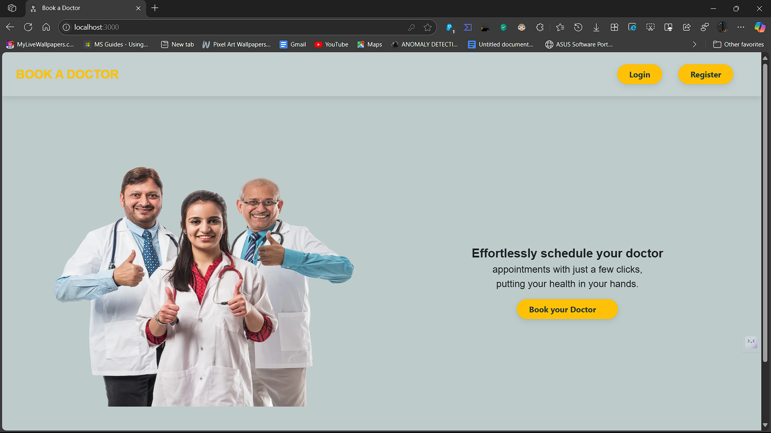

* **Login page :**
* 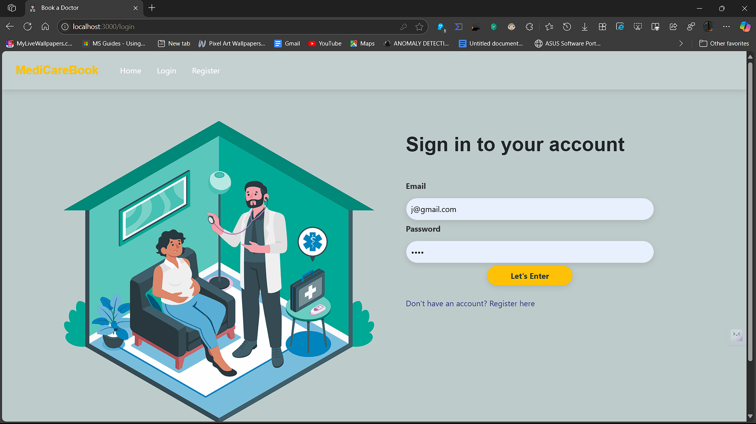
* **Registration page:**

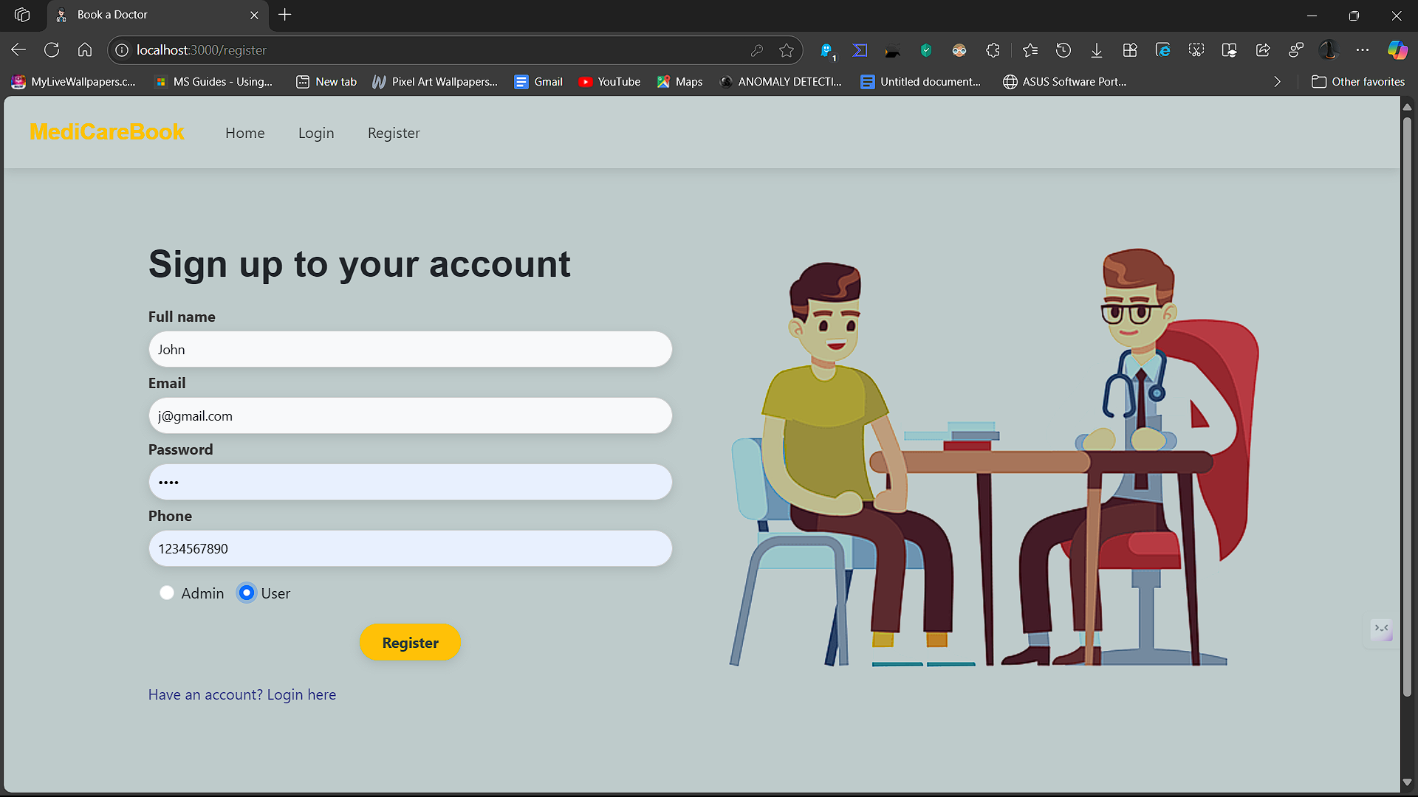

* **User page:**

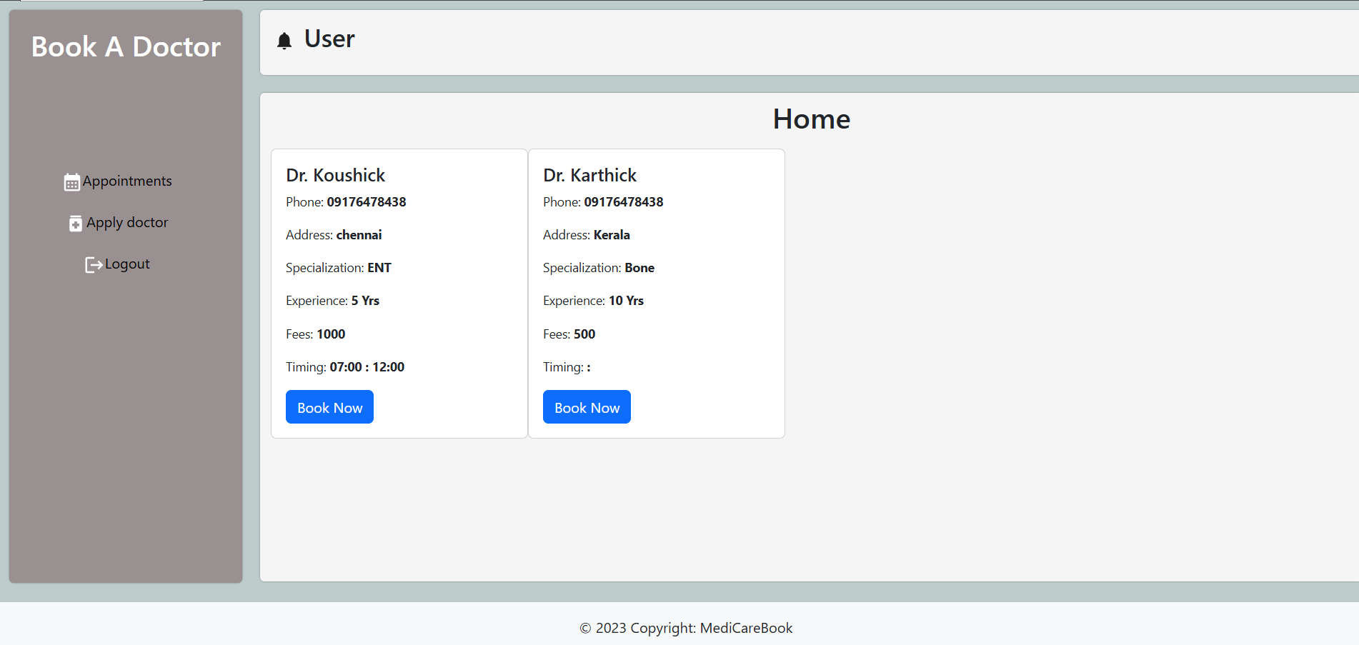

* **Admin page:**

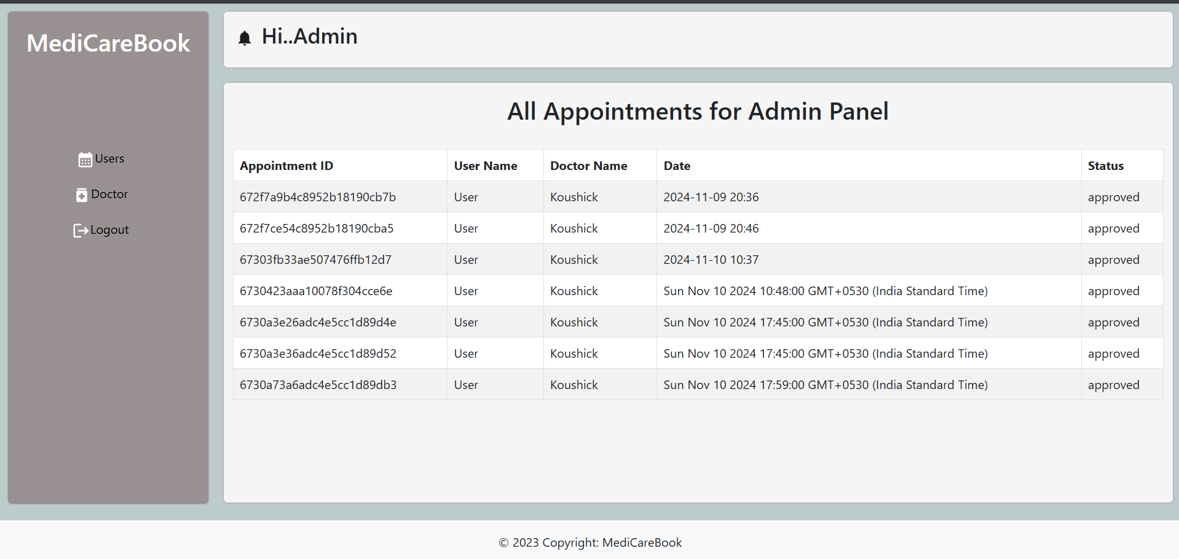

* **Apply as Doctor page:**

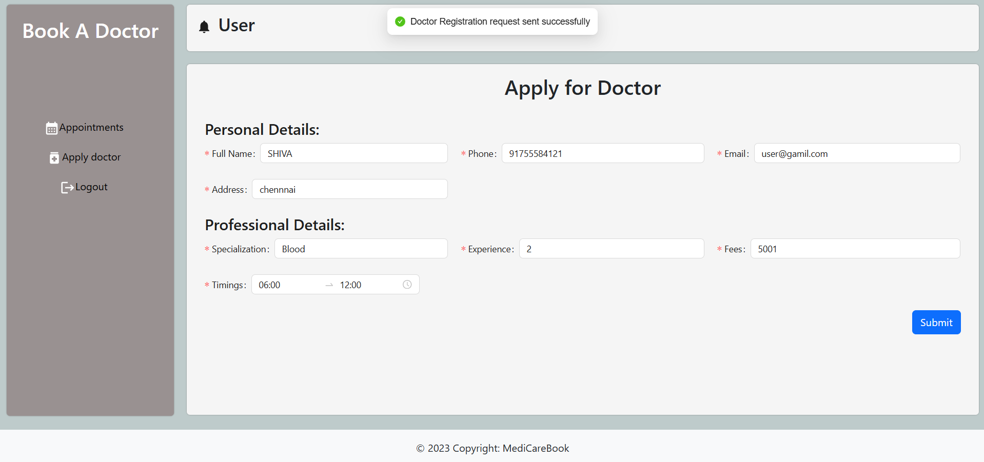

* **Admin Approve Doctor page:**

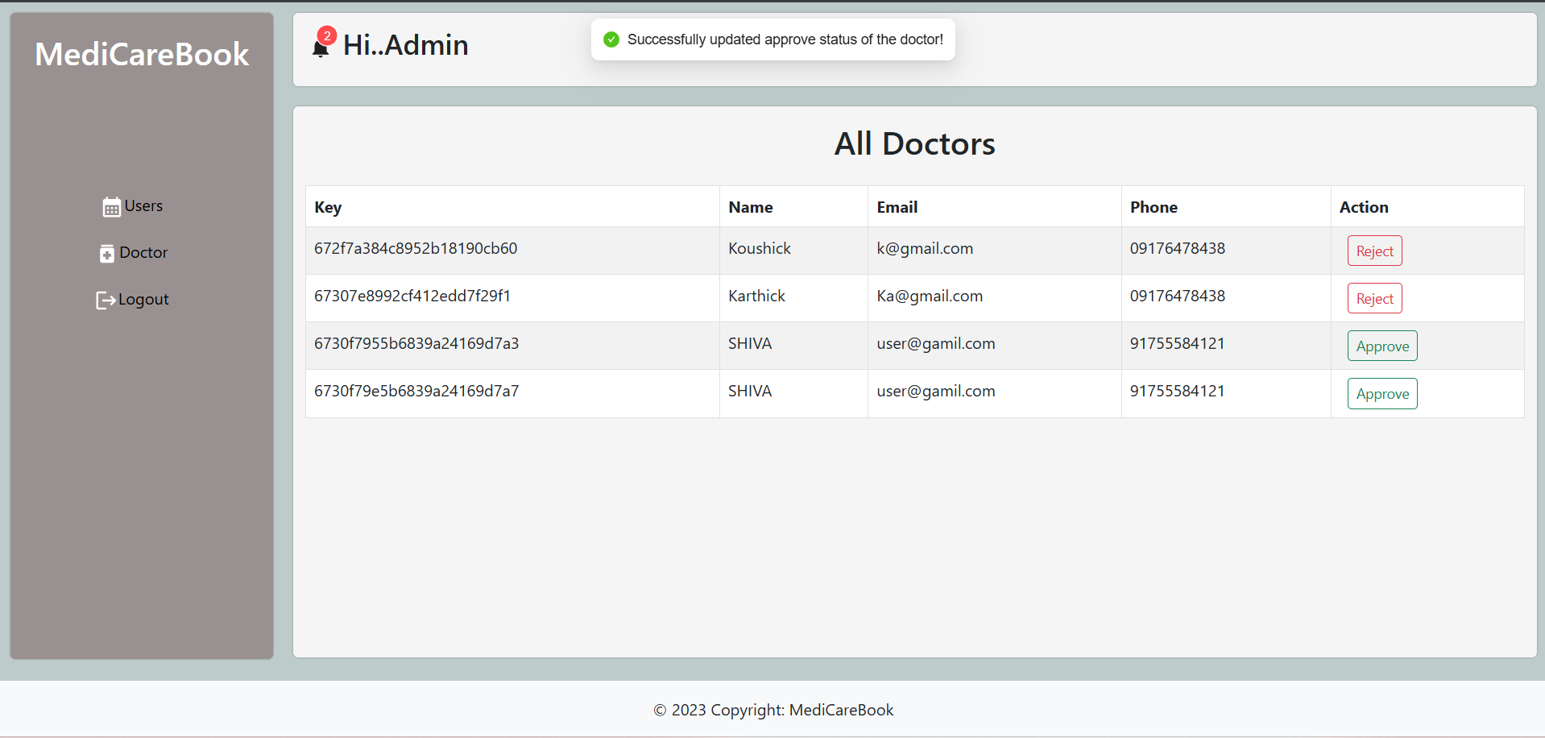

* **Book Doctor :**

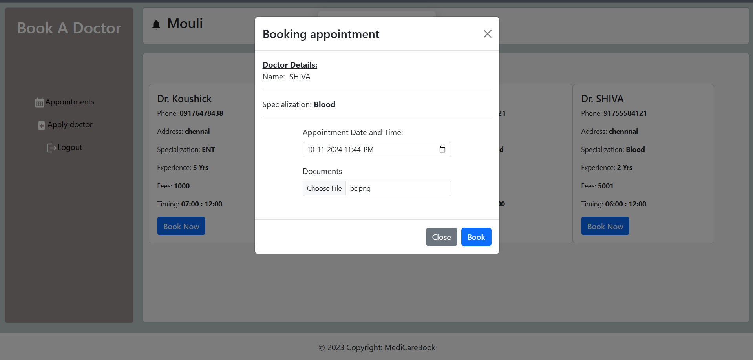

* **Doctor Approve User Appointment:**

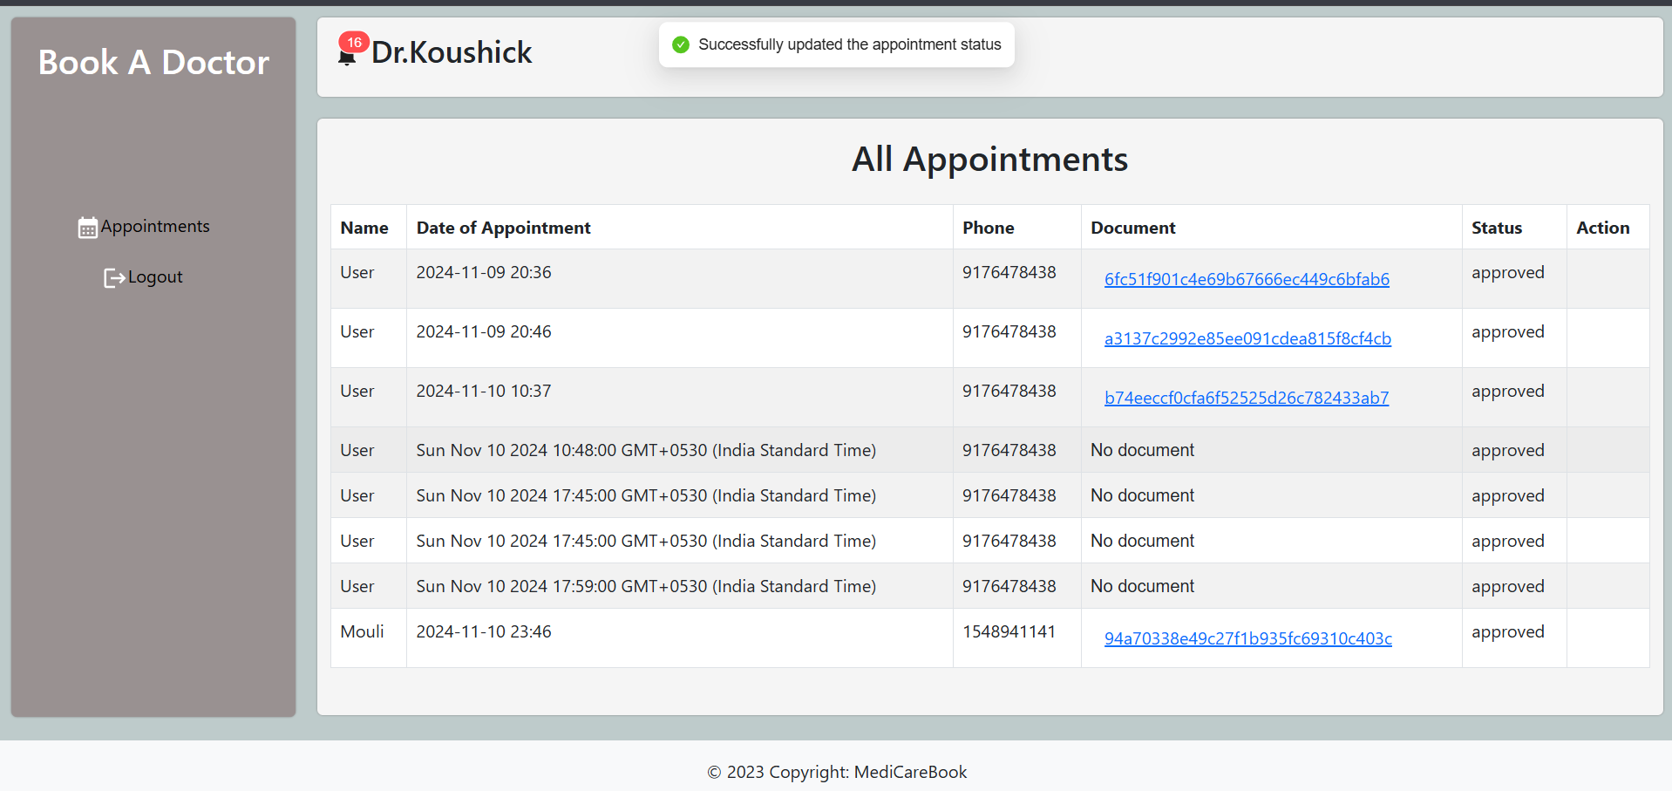

* **All History**



# 

# 9.ADVANTAGES & DISADVANTAGES

# Advantages:

## Improved Patient Experience Patients can book, reschedule, or cancel appointments easily, without long wait times or phone calls.

## Real-Time Scheduling Shows up-to-date doctor availability, reducing double bookings and improving time management.

## Reduced No-Shows Automated reminders via email/SMS help patients remember their appointments, reducing missed visits.

## 24/7 Accessibility The system is available anytime, allowing patients to manage appointments even outside clinic hours.

## Operational Efficiency Reduces manual work for staff by automating scheduling, notifications, and patient data handling.

## Data Accuracy and Security Digital records reduce human errors and ensure secure handling of sensitive patient information.

* **Scalable and Customizable**  
  Can be adapted to clinics of any size and extended with new features like telehealth or e-prescriptions.
* **Better Resource Utilization**  
  Helps doctors and clinics manage time effectively and fill open slots to serve more patients.

## Disadvantages

## Technology Dependency Patients or staff with limited digital literacy may struggle to use the system effectively, especially older adults.

## Internet Access Required The system needs a stable internet connection, which may not be available in rural or low-resource areas.

## System Downtime Risks Any server failure or technical glitch can temporarily block access to appointment services, causing inconvenience.

## Security & Privacy Concerns Handling sensitive health data requires strong security. Any breach could lead to legal issues and loss of trust.

## Initial Setup Costs Developing, hosting, and integrating such a system (e.g., with teleconsultation or EHR) can involve significant upfront investment.

## Resistance to Change Medical staff may resist shifting from traditional systems due to learning curves or workflow disruptions.

# CONCLUSION

The **Seamless Appointment Booking System for Healthcare** offers a modern, efficient solution to streamline the way patients, doctors, and clinics manage appointments. By automating scheduling, enabling real-time availability, and improving communication through timely notifications, the system enhances both patient satisfaction and operational efficiency.

While there are challenges such as user adaptability and the need for strong data security, these can be addressed with proper training, infrastructure, and compliance measures. Overall, the project supports digital transformation in healthcare by reducing wait times, minimizing errors, and making quality care more accessible and organized.

It is a valuable step toward building a more **patient-centered, efficient, and technology-driven healthcare system**.

* + - **Simplifies Appointment Booking**  
      Streamlines the scheduling process for both patients and healthcare providers.
    - **Enhances Patient Experience**  
      Offers convenience through 24/7 access, real-time availability, and instant confirmations.
    - **Boosts Operational Efficiency**  
      Reduces administrative workload with automated processes and centralized data management.
    - **Reduces No-Shows and Delays**  
      Improves appointment adherence through timely reminders and notifications.
    - **Secure and Scalable**  
      Ensures patient data is protected while supporting future expansion and integrations.
    - **Supports Digital Healthcare Goals**  
      Aligns with the vision of digitizing healthcare services and improving accessibility.

# FUTURE SCOPE

1. **Integration with Telemedicine Platforms**  
    Enable seamless video consultations directly from the appointment system

**2. AI-Powered Docto** **r Recommendations**  
 Use machine learning to suggest specialists based on patient history and symptoms.

**3. Multi-language Support**  
 Expand accessibility by adding support for multiple languages.

**4. Mobile App Development**  
 Build dedicated mobile apps for Android and iOS for improved user experience.

**5. Advanced Analytics & Reporting**  
 Provide clinics with insights on patient trends, appointment patterns, and resource utilization.

**6. E-Prescription and Billing Integration**  
 Automate prescription generation and payment processing within the system.

**7. Wearable Device Integration**  
 Incorporate health data from wearables to personalize care and appointment scheduling.

**8. Enhanced Security Features**  
 Implement biometric login, two-factor authentication, and blockchain for data security.

# APPENDIX

* **Source Code:** [**https://drive.google.com/drive/folders/1qrtpJE08Bnlh43CiQSrBnFHXsGtkAZlb**](https://drive.google.com/drive/folders/1qrtpJE08Bnlh43CiQSrBnFHXsGtkAZlb)
* **Project Demo Link: https://drive.google.com/file/d/1lINH7gble7W39IpcTMYNW7VUsu1uGbub/view?usp=drivesdk**